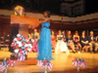

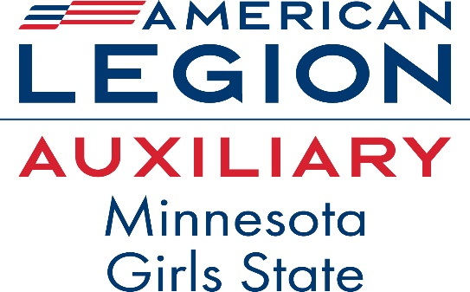

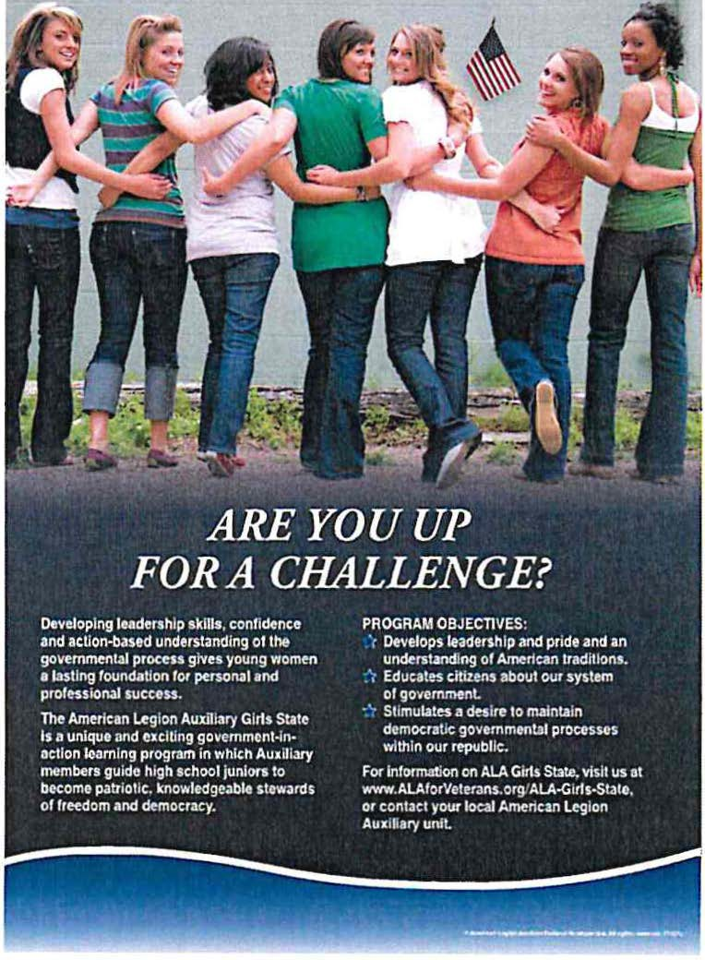

A premier program
in citizenship for
young women

June 15-21, 2025
Bethel University
St. Paul, Minnesota
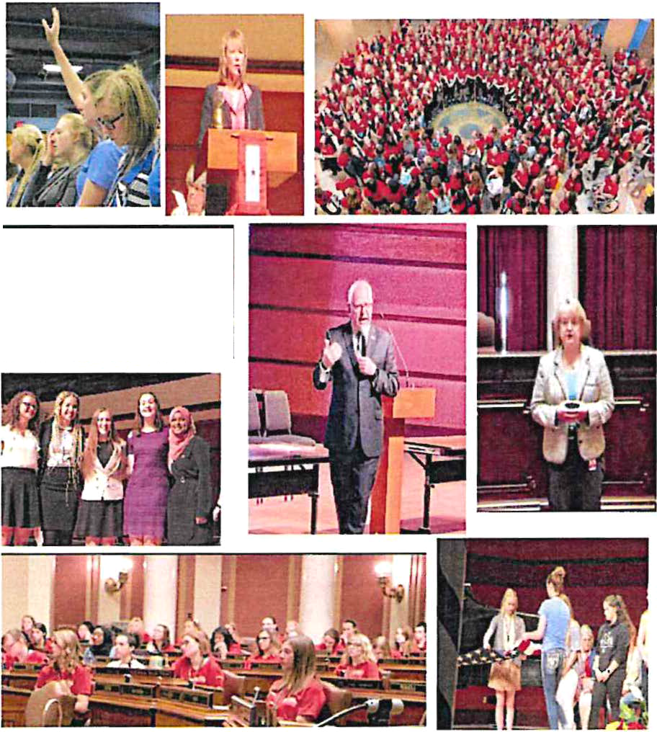

“Back to the Basics: Recognize, Respect, Remember”
is the theme for the year 2024-2025 for the ALA Department (State) President Judy Ackerman.

American Legion Auxiliary
Minnesota Girls State Committee

Peggy Tesdahl . . . . ... .Girls State Director
Amelia Tesdahl . . . . . . .Education Director
Wanda Prescher…. . .Girls State Chairman
Renee Suess…….. Girls State Committee
Jen Stolz……….. . . Girls State Committee
Kollett Kaehlert… ..Americanism Chairman
Judy Ackerman .. . . . State ALA President

https://www.mnala.org/girls-state/

AMERICAN LEGION AUXILIARY
GIRLS STATE HISTORY

The American Legion Auxiliary Girls State program, first presented in the late 1930s, is one of the most respected experiential learning programs in the United States. Guided by the principle “For God and Country,” the program epitomizes the ALA’s mission to honor those who have brought us our freedom by continuing to train young women to be leaders grounded in patriotism and Americanism. ALA Girls State participants become extremely knowledge-able about the democratic process and how our republic works at the state and national levels.

About 16,000 young women participate in weeklong ALA Girls State programs across the nation each summer that teach government from the city to state level. Using a nonpartisan curriculum, participants assume the roles of government leaders, campaigning as “Federalists” and “Nationalists” to become elected officials in their mock ALA Girls States. During the immersive learning program, delegates live in “cities” in a dormitory at Bethel University. The knowledge, memories, and friendships they take home last a lifetime.

ALA Girls State has been heralded by the National Association of Secondary School Principals (NASSP) and has been placed on the National Advisory List of Contests and Activities.

[To print (and preserve) these brochure instructions, click the Office button, point to Print, and then click Quick Print.]
[You can create a professional brochure using this template. Here’s how:]
- [Insert your words in place of these words, using or re-arranging the preset paragraph styles.]
- [Print pages 1 and 2 back-to-back onto sturdy, letter-sized paper.]
- [Fold the paper like a letter to create a two-fold brochure (the panel with the title “Adventure Words” is the front).]

[What else should I know?]
[To change the style of any paragraph, select the text by positioning your cursor anywhere in the paragraph. Then, select a style from the Paragraph group on the Home tab.]
[If you use a picture in your brochure, it is easy to change it. To change a picture, right-click the picture, and then click Change Picture. Select a new picture, and then click Insert.]
WHAT IS AMERICAN LEGION AUXILIARY MINNESOTA GIRLS STATE?

ALA Minnesota Girls State is a diverse group of young women who share a common desire to learn. From small towns to urban areas, the citizens' diverse backgrounds add spirit to the program. The purposes of the ALA Minnesota Girls State program are to provide Americanism and good citizenship training and to inform our participants about the duties, privileges, rights and responsibilities of government as practiced in a democratic society.
Each June, the ALA Minnesota Girls State "citizens" study the Minnesota city, county, and state governmental processes. Citizens are divided into two fictional political parties gaining knowledge of the operations of a two-party system. They formulate their cities electing the officials and then proceed on to county development and finalize with state government. Elections are held to fill city, county and state governmental positions. Activities include political party campaigning, caucusing, debating and voting. Parliamentary procedures are also used in the processes.

WHEN IS GIRLS STATE & WHERE IS IT HELD?
ALA Minnesota Girls State is a week-long session from Sunday, June 15th to Saturday, June 21st, 2025. ALA MN Girls State is held at Bethel University in St. Paul, MN.

HOW DO I GET TO GIRLS STATE? WHAT DO I NEED?

The sponsoring ALA unit or the participants family is responsible for transportation to and from Bethel University. A complete list of items to bring will be sent to citizens once registration has been completed.

ELIGIBILITY & OUALIFICAT/ONS
- She must have completed her junior year of high school in a Minnesota public, charter, home school, parochial or private school or be a resident of Minnesota and have at least one more semester remaining prior to graduation.
- She must be a citizen of the U.S. or have legal residency.
- She must have high moral character with strong leadership abilities.
- She must have no marital status. (National ALA Mandate)
- She must not have attended any other ALA Girls State session.
- She must demonstrate an interest in American government and have an above average scholastic rank.
- She must be physically healthy and able to live independently.
- She must respect the American flag and be willing to pledge allegiance to it.
- Or be an ALA junior member in the state of Minnesota that meets this same criteria.
- No citizen should be sent to ALA Minnesota Girls State who has any other obligations during American Legion Auxiliary Minnesota Girls State week. NO citizen may arrive late or leave before the close of the final session.
Final selection of the candidate is the decision of the local American Legion Auxiliary units. The units work with high school principals, counselors or other faculty, community leaders and clergy, who assist in evaluating the qualities of the candidates.

ADDITIONAL ACTIVITIES
ALA Minnesota Girls State offers hands­ on experience in how state governments function. Other activities at ALA Girls State foster fellowship & creative expression:
Reporting
Public Speaking & Debate Singing -Talent Show Patriotic Ceremonies
Mock Judicial Court System
Mock House & Senate Committees

American Legion Auxiliary Minnesota Girls State has empowered hundreds of thousands of accomplished young women to aspire to great things. Their stellar achievements are grounded in leadership skills enhanced at ALA MN Girls State. Former ALA MN Girls State participants include members of Presidential cabinets, Mayors, Governors, State Representatives, U.S. Senators, corporate CEO's, military officers and more.

