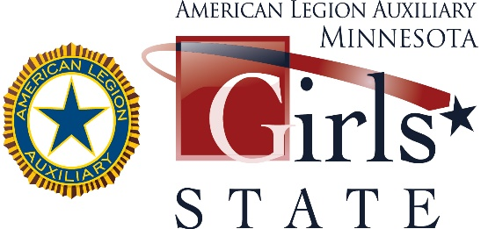

American Legion Auxiliary Minnesota Girls State

The 77th session of American Legion Auxiliary Minnesota Girls State will be held June 9-15, 2024, at Bethel University in Arden Hills. The ALA MN Girls State citizens will arrive on Sunday and leave on Saturday morning before noon. The ALA MN Girls State committee has made the decision to keep attendance to 200 participants for the 2024 session.

The school mailing to principals was mailed in January. The schools are aware that units will be contacting them to set up an appointment to meet with potential candidates from the Junior High School class to attend the 2024 ALA MN Girls State session. Please read all the information we have provided so that you are aware of the eligibility and qualifications required.
- 2024 eligibility updated to include MN ALA junior members living out of state and meeting all other criteria.

There is no limit to the number of girls a Unit may sponsor to ALA Minnesota Girls State.

The registration fee remains at $300 per citizen for the 2024 session. If there are no high schools in your community, please consider sponsoring or co-sponsoring a girl(s) from the Junior class in a neighboring community.

What can your Unit do to raise funds to send a girl to Minnesota Girls State? Here are a few suggestions:
- Units may hold different types of fundraising events
- Charitable Gambling funds may be used for the reservation fee only.
If gambling funds used make checks payable to: American Legion Auxiliary Foundation.
- Donations can be received from local businesses and/or community organizations.
- Their checks need to be made out to your Unit and then your Unit sends a check to the Department office for the reservation fee.
- Ask your American Legion Post or Sons of The American Legion Squadron to sponsor a girl or girls by writing a check to the American Legion Auxiliary.

A resolution, passed at the 2011 Department Convention, states that monies sent to the Department Office for reservations not used to sponsor a girl to ALA Minnesota Girls State would be placed into a Girls State Reservation Fee Fund. This fund is available for any unit to use one time every 3 years on a first come-first serve basis. If your Unit has a girl who is interested in attending and you do not have enough funds to reserve a place for her, consider applying to the Department Office in writing to request these funds.
All reservations are due by March 31st accompanied by your check. Once your Unit has submitted your reservation and payment of $300.00 per girl, you will be sent a Registration Packet. This packet will be sent to the name listed on the Reservation Form. The paperwork included in this packet has due dates listed which must be followed. It is important that you read the Registration Packet thoroughly before you share it with your citizen. Please remember there are NO late arrivals and NO early dismissals. The 2024 Girls State session begins promptly at 3:00 pm on Sunday, June 9th and ends on Saturday morning June 15, 2024.

The name(s) and email address of your girl(s) are due to the Department office by May 1, 2024. Our contract with Bethel University requires that we commit to a final number of reservations for citizens and staff on that date, so the deadline is very important.

The ALA Minnesota Girls State Committee has been working diligently to ensure that our citizens have a truly memorable week at ALA Minnesota Girls State. We look forward to welcoming a participant representing your unit and community.

Please refer to the Auxiliary web page at mnala.org for forms and other information about Girls State.
If you have questions, feel free to contact any of the members of the Department Girls State Committee. We are here to assist you!

Linda Kelly, Girls State Chairman Patti Coleman, Girls State Director

Bethany Dickert, Girls State Education Director Jessie Hoppe, Girls State Committee Member

Lynn Carr, Girls State Committee Member Mary Kuperus, Americanism Chairman

Linda Kelly – Department Girls State Chairman
Cell: 507-421-8270 Email: lkkauxiliary@gmail.com

Patti Coleman – Girls State Director
Cell: 763-354-8644 Email: pjc3555@aol.com

