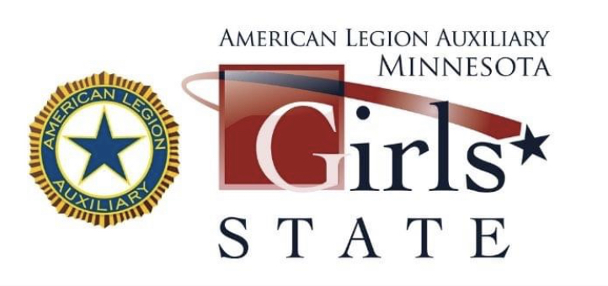
American Legion Auxiliary
20 W 12th St #314, St. Paul, MN 55155
Phone: 651-224-7634 Fax: 651-224-5243 Toll Free: 888-217-9598
Email – deptoffice@mnala.org

To: Minnesota School Superintendents/ Principals: January 2024

The American Legion Auxiliary is sponsoring its 77th annual American Legion Auxiliary Minnesota Girls State program Sunday thru Saturday, June 9-15, 2024 at Bethel College.

This is one of our most premier programs and we are very proud of it. There is no cost to the student, their family, or the school. The sponsored student(s) must have just completed their Junior year of High School.

This letter is asking you to find someone within your staff that would take an interest and assist your local American Legion Auxiliary Unit to choose one or more of your students to participate in this program. It may be an alumnus of our program, your Government Class instructor, a counselor, or someone on staff that will take an interest.

This program gives students many opportunities. They learn to become good, conscientious citizens, that participate in our election process. They elect officials and the city, county, and state level. Many speakers will share their experience in the three branches of our government. A sample day is included.

Your local American Legion Auxiliary Unit has the necessary forms to register a citizen(s) for the program and will contact you soon. Your local unit may ask for assistance in the selection of a citizen who has demonstrated leadership ability and is interested in government. Interested students will complete an application and be interviewed by your local unit.

Your cooperation in allowing the Unit members to communicate with the junior class girls for this purpose is greatly appreciated.

Thank you for the assistance you have given this program in the past and for your part in assisting the Unit with the selection of a citizen this year.

Linda Kelly, Program Chairman Patti Coleman, Director
lkkauxiliary@gmail.com pjc3335@aol.com

